2016 AFC Region II, Campus Safety and
Facilities Commissions presents

Spring Collaboration Conference
Connect, Collaborate…Take Action!!!
Hosted by:

Friday, April 1, 2016
Santa Fe College, Northwest Campus
3000 NW 83rd Street, Gainesville, FL 32606

NAME:

TITLE/INSTITUTION:

EMAIL:

PHONE:
FAX:
Special Dietary Needs:

CONFERENCE FEES: Registration includes: Continental breakfast, lunch at the campus, and conference materials.

Early Registration: On or before March 18, 2016 $50.00 Please select one: Region II-Chapter

Late Registration: After March 18, 2016 $65.00 Campus Safety Commission

Non-AFC members attending AIA session $50.00 by March 18 Facilities Commission

PAYMENT INFORMATION: Make checks payable to AFC
Mail: Rebecca Rogers
Santa Fe College
3000 NW 83rd Street, Bldg. U-028
Gainesville, FL 32606
For more information: http://www.SFcollege.edu/AFC
Rebecca Rogers • (352) 395-5174 FAX (352) 395-7356 • rebecca.rogers@sfcollege.edu
Area Map - Gainesville

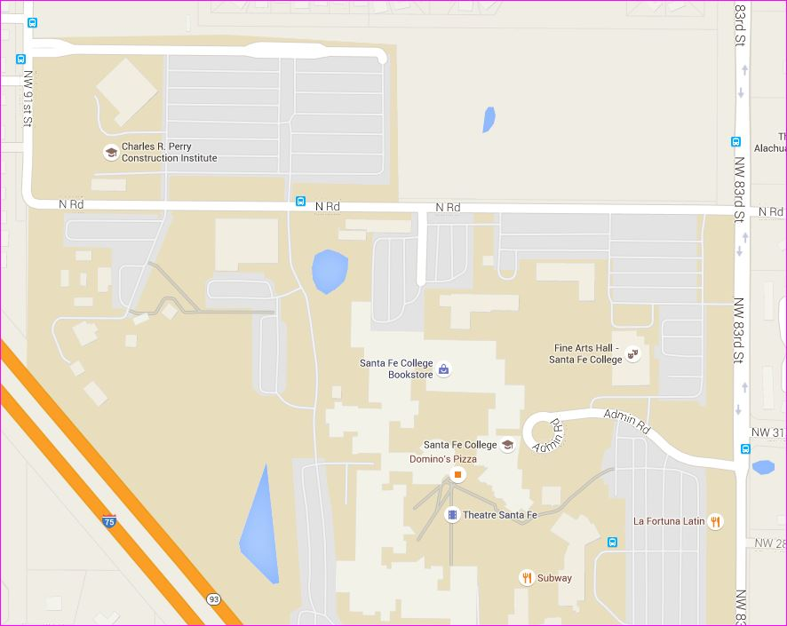
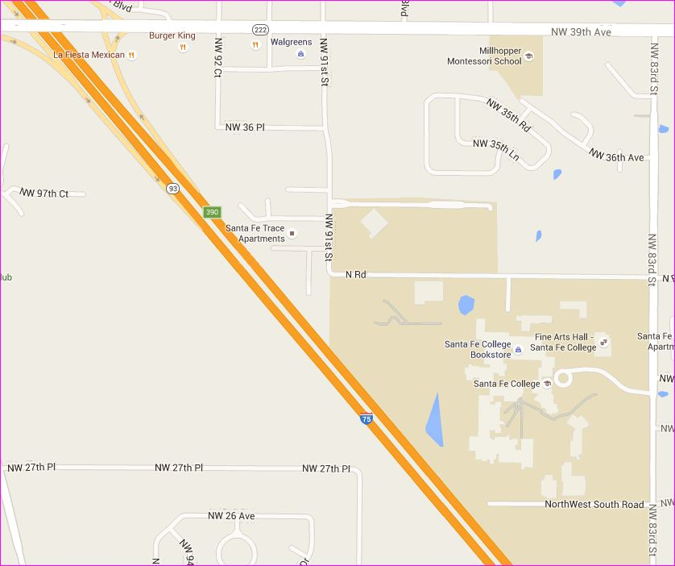
Directions to Santa Fe College Northwest Campus
3000 NW 83rd Street
Gainesville, FL 32606

From I-75 South:
Take the SR-222 exit - Exit 390
Turn right onto SR-222. Continue for approximately 2 miles.
Turn right at NW 83rd Street.
Drive up hill and turn right onto Center Drive
at the Fine Arts Hall.

From I-75 North:
Take the SR-222 Exit 390
Turn left onto SR-222, cross overpass.
Continue for approximately 2 miles. Turn right on NW 83rd Street. Drive up hill and turn right
onto Center Drive at the Fine Arts Hall.

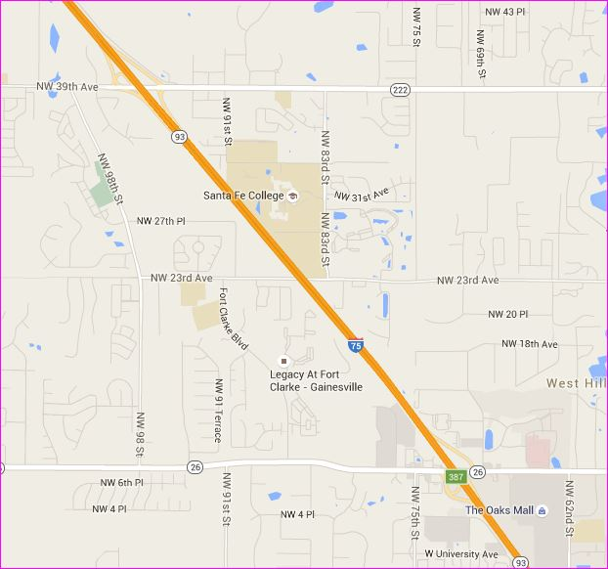

Santa Fe College - Northwest Campus Map

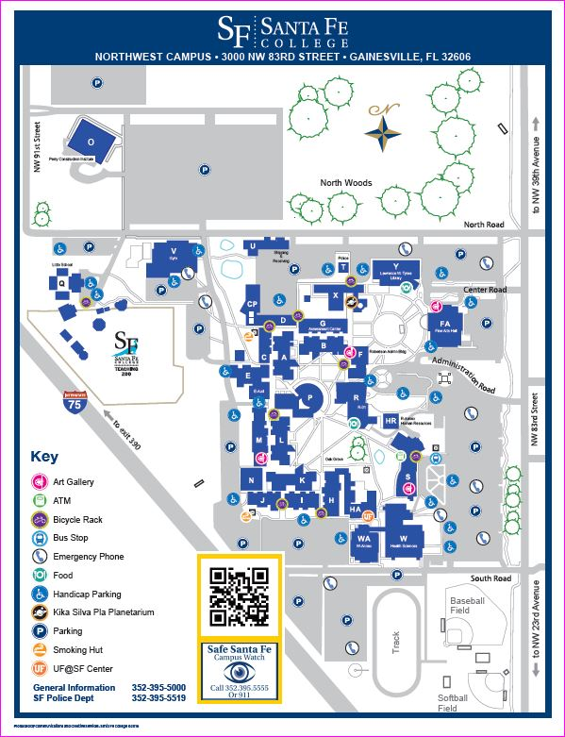
Fine Arts Hall
~ Lobby~

Registration and Conference Meeting

Sessions to be held in multiple locations:
B-012
R-001
Y-102, 130

Hotel Information:

Best Western Gateway Grand
4200 NW 97th Blvd.
Gainesville, FL 32606
352-331-3336 or 352-331-7104

Mention Association of Florida Colleges for a special room rate of $169 for a studio King room. Must book by March 1.

http://www.gatewaygrand.com/?WT.srch=1&WT.mc_id=PPC2P&DCSext.ppc_kw=best+western+gateway+grand&ppc_ac=Brand&ppc_ag=Brand+Exact&ppc_mt=Exact&platform=c

TownePlace Suites
7451 W. Newberry Road
Gainesville, FL 32605
352-415-1111

Mention Association of Florida Colleges for a special room rate of $129 Studio King room or $149 Studio Double. Must book by March 1.
http://www.marriott.com/hotels/travel/gnvnw-towneplace-suites-gainesville-northwest/

